**Session No. 28: Recent Application of Artificial Intelligence and Machine Learning**

“ML-Driven Early Detection for Optimal Health – Empowering You with Accurate Predictive Health Analytics”

# 

**Dr. Anil V Turukmane**

**School of Computer Science and Engineering**

**VIT-AP University, Vijaywada, AP, India**

[**anil.turukmane@vitap.ac.in**](mailto:anil.turukmane@vitap.ac.in)

**Mr. Kaarthikeya Kothamasu**

**Student**

**School of Computer Science and Engineering**

**VIT-AP University, Vijaywada, AP, India**

[**kaarthikeya21mis7039@vitapstudent.ac.in**](mailto:kaarthikeya21mis7039@vitapstudent.ac.in)

**Mr. Madhu Alapaka**

**Student**

**School of Computer Science and Engineering**

**VIT-AP University, Vijaywada, AP, India**

[**madhu.21mis7022@vitapstudent.ac.in**](mailto:madhu.21mis7022@vitapstudent.ac.in)

**Mr. Pulluru Nikhilesh**

**Sudent**

**School of Computer Science and Engineering**

**VIT-AP University, Vijaywada, AP, India**

[**nikhilesh.21mis7087@vitapstudent.ac.in**](mailto:nikhilesh.21mis7087@vitapstudent.ac.in)

***Abstract*—In the realm of early disease detection, our study presents a robust predictive model that addresses the challenges of diagnosing five critical health conditions: heart disease, diabetes, kidney disease, Parkinson's disease, and Hepatitis C. By evaluating various machine learning algorithms, we identified optimal models tailored to each disease, enhancing diagnostic accuracy and reliability. For heart disease and Hepatitis C, Random Forest (RF) emerged as the superior algorithm, achieving accuracies of 99% and 94%, respectively. In contrast, Gradient Boosting (GB) proved highly effective for diabetes and kidney disease, with accuracies of 91% and 99.25%, while K-Nearest Neighbors (KNN) demonstrated significant efficacy for Parkinson’s disease with an accuracy of 95%.**

**Incorporating state-of-the-art ML technology into an approachable Streamlit platform, this initiative not only facilitates informed decision-making but also improves overall disease management. The deployment of this comprehensive predictive system provides a user-friendly interface for healthcare professionals, enabling them to efficiently diagnose and monitor these conditions. This approach represents a significant advancement in predictive healthcare technology, offering a reliable tool for early detection and personalized patient care, ultimately contributing to better health outcomes through targeted interventions.**

***Index Terms*—MachineLearning(ML), Disease Prediction, Stream- lit, Python, Healthcare, Early Detection, Risk Assessment, Predictive Analytics.**

1. INTRODUCTION

In recent times, the integration of machine knowledge( ML) into healthcare has revolutionized early complaint discovery and threat assessment. This design focuses on developing a Multiple Disease Prediction System that leverages machine literacy ways to prognosticate the liability of conditions similar to Diabetes, Heart Disease, Parkinson’s, order, and Hepatitis C conditions. By exercising patient data, the system aims to enable timely medical intervention and substantiated healthcare operation through a stoner-friendly interface erected on Streamlit.

1. *Background and Motivation:*

The rising frequency of habitual conditions necessitates early discovery systems for better health operation. Machine literacy offers promising capabilities in prophetic analytics. The burden of habitual conditions similar to Diabetes, Heart Disease, Parkinson’s complaint, order complaints, and Hepatitis C has been steadily increasing worldwide. These conditions pose significant challenges to healthcare systems due to their long-term treatment conditions and the high costs associated with managing complications. Beforehand discovery of these conditions is pivotal, as it can lead to better operation, reduced healthcare costs, and better patient issues. still, traditional individual styles frequently calculate on homemade interpretation, which can be time-consuming and subject to mortal error. The arrival of machine literacy offers new possibilities for developing automated, accurate, and effective prophetic systems that can help healthcare professionals in early complaint discovery. The field of medical diagnostics has seen significant pledges from machine literacy styles. These algorithms can find patterns and correlations in massive datasets that mortal interpreters would miss. While machine literacy has proven to be useful in history for prognosticating individual conditions, there's still a significant gap in the development of integrated systems that can prognosticate multitudinous conditions at formerly. A thorough health assessment can be handed via an intertwined system, which will increase individual process effectiveness overall and allow for further visionary healthcare operations. likewise, the use of similar vaticination technologies in factual healthcare settings depends heavily on their usability and availability. It's possible to close the communication gap between sophisticated machine literacy models and end druggies, similar to cases and healthcare providers, by planting these systems through approachable platforms like Streamlit. Streamlit makes it possible to develop interactive web operations that indeed techies may use to readily pierce advanced prophetic tools. This design aims to develop a robust multiple-complaint vaticination system that can support early discovery and visionary healthcare operation, eventually perfecting patient quality of life and health issues. It does this by combining the power of machine literacy with the ease of use and availability of Streamlit.

1. *Problems In The Existing System:*

Current disease prediction systems face several significant challenges that impact their effectiveness and accessibility. A primary issue is the lack of early detection, as existing systems may not provide timely identification of multiple diseases. This delay in detection can result in worsening conditions and diminished treatment effectiveness. Additionally, limited access to diagnostics is a critical concern; many patients are unable to access comprehensive diagnostic facilities due to geographical or financial constraints, which hampers their ability to obtain timely and accurate diagnoses. Another challenge is the fragmentation of patient health data, which is often dispersed across various sources. This scattered data makes it difficult to aggregate and analyze comprehensively, leading to incomplete or inaccurate predictions. Furthermore, the complexity of current predictive tools can be a barrier to their effective use, as many of these tools are not user-friendly and can be difficult for healthcare providers and patients to utilize. This complexity often results in the underutilization of these tools. Finally, traditional prediction methods may lack advanced machine-learning techniques, leading to lower prediction accuracy. This limitation can contribute to misdiagnoses or missed diagnoses, adversely affecting patient care.

This design's main thing is to use machine literacy ways to produce a comprehensive Multiple Disease Prediction System. Beforehand identification and threat assessment for several habitual ails, similar as diabetes, heart complaint, Parkinson's complaint, order complaint, and hepatitis C, are the main pretensions of the system. The system uses a variety of machine-literacy ways to give reliable and accurate prognostications grounded on data entered by druggies. This thing includes every step of the process, from gathering data and preprocessing to training, assessing, and planting models. Another crucial idea is to optimize each complaint vaticination model to insure robustness and high performance. This involves opting and tuning the best- suited machine literacy algorithms for each specific complaint, considering the unique characteristics and threat factors associated with each condition. High delicacy, perfection, recall, and F1 scores may be attained by the system to give dependable vaticinations that cases and healthcare providers can calculate on to make educated opinions. Last but not least, the design intends to work a web operation erected on Streamlit to emplace the vaticination system and make it accessible and stoner-friendly. Creating an easy- to- use interface that enables druggies to snappily enter their health data and get vaticinations is part of this thing. The ideal is to give a smooth stoner interface that supports visionary health operation and early illness opinion by making the system easier to use in real- world healthcare settings. The design's compass includes numerous pivotal phases, beginning with data gathering and medication. This involves gathering applicable datasets for Diabetes, Heart Disease, Parkinson’s complaint, order complaint, and Hepatitis C from estimable sources. The data will suffer thoroughpre-processing, including cleaning, normalization, and running of missing values, to insure it's suitable for model training. point engineering will also be performed to elect and produce applicable features that enhance the prophetic power of the models. The design includes the development and training of multiple machine- literacy models, each acclimatized to a specific complaint. Every condition will be delved and optimized using a variety of styles, including Support Vector Machines, Random timbers, Decision Trees, and Logistic Retrogression. A thorough assessment of these models' performance will be conducted using measures like delicacy, perfection, recall, and F1- score.

This stage ensures that the models are not only accurate but also reliable and generalizable to new, unseen data. Finally, the project scope extends to the deployment of the trained models into a user-friendly web application using Streamlit. This involves integrating the models into the application, designing the user interface, and ensuring the system operates smoothly and efficiently. Early illness identification and proactive healthcare management will be made easier for users of the online application, which will allow them to enter their health data and obtain fast forecasts. The project also has future-updating and -improving features, so that the system stays current with the most recent medical research and technical developments.

.

1. LITERATURE REVIEW

In their study" AComprehensiveWeb operation for habitual order Disease Prediction with Cuisine- CentricDietRecommendation," Arun Deepak K G et al. ( 2023) produce an intertwined system for machine literacy-grounded early discovery of habitual order complaint( CKD) and combine it with a diet recommender to stop the complaint's progression. The system is erected using Flask and is stationed on IBM Cloud. order Guard is a web operation that provides CKD vaticination, diet recommendations, and stoner engagement tools, similar to motivator chatbots, manual form capitals, and exercise trackers. This approach helps croakers identify habitual order complaints beforehand and helps cases stick to the salutary changes that are pivotal for managing the condition [1]( 21).

Mana Saleh Al Reshan etal.( 2023) in their exploration ” A Robust Heart Disease Prediction System Using Mongrel Deep Neural Networks ” employ deep literacy ways, specifically cold-blooded deep neural networks( HDNNs) combining CNN and LSTM infrastructures, for heart complaint vaticination using colorful datasets, including the Cleveland heart complaint dataset. The advantages include the models’ capability to learn complex patterns and connections from data, leading to enhanced vaticination delicacy. still, these models can be computationally ferocious and bear significant computational coffers for training. also, large quantities of labeled data are necessary for effective training, which might not always be available for all heart complaint cases [2] ( 22).

John Peter andK. Somasundaram( 2012) conducted exploration named" An Empirical Study on vaticination of Heart Disease Using Bracket Data Mining ways," where they explore the operation of bracket data mining styles to prognosticate heart complaint. The study evaluates several algorithms, including Naive Bayes, K- Nearest Neighbor, Decision Tree, and Neural Network, and addresses the limitations of traditional medical scoring systems, similar as their incapability to model complex nonlinear relations. Their findings indicate that the Naive Bayes classifier achieves the loftiest delicacy among the estimated styles. also, the performance and delicacy of the bracket models are enhanced by reducing the dimensionality of the data using trait selection ways. This approach is salutary for cardiovascular clinicians as it improves the vaticination and bracket of heart complaint grounded on case records, though it can be time-consuming to classify large datasets [3]( 23).

In 2021, Puneet etal. published a study named" Coronary Heart Disease Prediction Using Voting Classifier Ensemble Learning," in which they employ machine literacy ways, specifically ensemble literacy, to prognosticate coronary heart complaints. The study utilizes classifiers similar to K- Nearest Neighbors( KNN), Support Vector Machine( SVM), Decision Tree, and Random Forest, combining their prognostications through Hard Voting Classifier( HVC) and Soft Voting Classifier( SVC) styles. This ensemble approach enhances delicacy and handles complex data patterns effectively. still, the models bear substantial computational coffers and careful operation of class imbalances. The study reports that the loftiest delicacy achieved is83.2 with HVC and82.8 with SVC, showcasing the efficacity of ensemble ways in medical vaticination tasks [4]( 24).

Deep literacy ways, further especially a CNN- grounded unimodal complaint threat vaticination( CNN- UDRP) algorithm, are used in Sayali Ambekar and Rashmi Phalnikar's( 2008) study," Disease Risk Prediction by Using Convolutional Neural Network," to prognosticate the threat of heart complaint. In order to address missing medical data, the study uses preprocessing ways similar as data drawing and insinuation. Naive Bayes and KNN algorithms are used for original bracket. Next, it's determined by the CNN- UDRP algorithm if a case has a high or low threat of developing heart complaint. The system's threat vaticination delicacy is further than 65. Among the benefits is the capacity to automatically prize material characteristics. from huge datasets and produce precise vaticinations, yet there are difficulties in handling missing data and a need for substantial computer coffers [5]( 25).

AH Chen etal.( 2011) developed a system called" HDPS Heart Disease Prediction System," designed to prop medical professionals in prognosticating heart complaint status using clinical data. The system employs an artificial neural network( ANN) algorithm trained on 13 crucial clinical features, including age, coitus, casket pain type, resting blood pressure, and cholesterol situations. The HDPS system features an easy- to- use interface and offers tools similar as ROC wind display and vaticination performance criteria . It achieves an delicacy of roughly 80, with a perceptivity of 85 and a particularity of 70. Although the ANN approach effectively classifies heart complaint, it faces challenges related to icing high- quality training data and acceptable computational coffers [6]( 26)

In 2022, Karthikeyan etal. developed a system named" Multi Disease Prediction System using Random Forest Algorithm in Healthcare System," which assists medical professionals in prognosticating the status of heart complaint, diabetes, and order complaint using clinical data. The system leverages the Random Forest Algorithm, trained on pivotal clinical features like palpitation rate, cholesterol, blood pressure, and heart rate. It features an intuitive interface and provides criteria similar as delicacy, perfection, recall, and F1- Score. The system achieves an delicacy of98.05 for heart complaint,92.30 for diabetes, and99.17 for order complaint. While the Random Forest system effectively classifies these conditions, it faces challenges similar as the need for high- quality training data and sufficient computational coffers [7]( 27).

In 2023,Gopisetty etal. developed a system named" Multiple Disease Prediction System Using Machine Literacy and Streamlit." This system employs colorful machine learning algorithms to prognosticate conditions similar as diabetes, heart complaint, and order complaint. The primary algorithms employed include Random Forest, SVM, KNN, Decision Tree, Naive Bayes, and Logistic Retrogression. The system achieves different situations of delicacy for each complaint98.3 for diabetes using Random Forest,89.9 for heart complaint using SVM with a radial base kernel, and 99.17 for order complaint using Random Forest. The interface, created with Streamlit, provides features similar to ROC wind display and performance criteria . still, challenges similar as data quality and computational coffers are noted [8]( 28).

J. Mathews etal.( 2023) conducted a study named" Multiple Disease Prediction System Using Machine Literacy," which focuses on prognosticating multiple conditions, including heart complaint, Parkinson’s complaint, bone cancer, and diabetes, through colorful machine literacy( ML) algorithms. The exploration compares the performance of Logistic Retrogression( LR), Support Vector Machine( SVM), Decision Tree, and Random Forest classifiers, chancing that LR and SVM deliver superior performance. The system employs data preprocessing ways similar as star element Analysis( PCA) and correlation matrices to reduce features while maintaining delicacy. The study reports the loftiest rigor as 77 for diabetes using LR, and 80, 92, and 97 for heart complaint, Parkinson’s complaint, and bone cancer, independently, using SVM. The integrated frame is stationed as a web operation to enhance stoner experience, emphasizing the need for effective data preprocessing and sufficient computational coffers for optimal ML model performance [9]( 29).

1. METHODOLOGY
2. *Data Collection and Preprocessing*

One of the most important original ways of developing a MultiDiseasePrediction System is gathering data. The design is using datasets from Kaggle, a popular platform for participating datasets, including Diabetes, Heart Disease, Parkinson's complaint, order complaint, and hepatitis C.These datasets are named grounded on their comprehensiveness and applicability to the conditions in question. Each dataset undergoes a thorough amination to insure it includes a sufficient number of records and a variety of features that can contribute to accurate complaint vaticination. Preprocessing the data is essential to prepare it for model training. This requires a number of way addressing missing values to keep them from distorting the model's performance, drawing the data to remove crimes or inconsistencies, and homogenizing the data to make sure every point contributes inversely to the vaticination process. likewise, the data is divided into testing and training sets in order to duly assess the models. To duly convert raw data into a format that machine literacy algorithms can use, these preprocessing processes are essential. The preprocessing channel also includes the encoding of categorical variables and point scaling. For algorithms that are sensitive to point magnitude, spanning guarantees that numerical features are on a analogous scale. Categorical variables are decoded to convert them into a numerical format that machine literacy models may use. We guarantee that the models admit clean, precise, and well- structured input by precisely preprocessing the data, which is essential to their responsibility and performance.

.

1. *Feature Engineering*

The step of point engineering is essential to creating machine literacy models that work. It entails choosing the most material characteristics from the datasets that have a major impact on each complaint's cast. originally, an exploratory data analysis( EDA) is conducted to ascertain the distributions, correlations, and significance of distinct features included in the datasets. EDA makes it easier to determine which traits are more prophetic and which may be gratuitous or spare. point engineering might involve developing new features to ameliorate the prophetic power of the model in addition to choosing preexisting bones

. This can involve producing polynomial features, commerce terms, or meaningfully combining formerly- being features. For case, the combination of age and BMI( body mass indicator) may be suitable to prognosticate some conditions more directly than either metric alone. Adding features to the dataset that give a deeper understanding of the underpinning patterns linked to each complaint is the end. Reducing the quantum of features without immolating the most pivotal information can also be fulfilled by using dimensionality reduction ways like star element Analysis( PCA). This aids in streamlining the models dwindling computational complexity, and potentially perfecting performance. By precisely negotiating features, we aim to maximize the models’ capability to directly prognosticate complaint issues while ensuring they remain interpretable and effective..

1. *Model Training*

Model training is the core phase where the machine literacy algorithms learn from the preprocessed data to make prognostications. This design involves training multiple models, each acclimatized to prognosticate a specific complaint of diabetes, hepatitis C, order complaint, Parkinson's complaint, and diabetes. To find the optimum machine learning algorithm for each complaint, experimenters probe a variety of styles, including Support .Vector .M.achines( SVM), Random.Forest, Decision.Trees, and Logistic Retrogression. Every algorithm is tutored using the training subset of its corresponding dataset. A pivotal element of training a model is optimizing its hyperparameters. The stylish collection of hyperparameters that maximize the performance of the model is set up using styles like Random Search and Grid Search. The procedure entails modifying variables similar as regularization strength, learning rate, and tree depth to ameliorate the delicacy and generalizability of the model. To make sure the models aren't overfitting and can effectively generalize to the new data, cross-validation is also employed. The models are assessed on a range of performance criteria, including delicacy, perfection, recall, and F1- score, during the training process. These measures show how effectively the models are working and point out any areas that bear development. The ideal is to produce reliable, dependable models that, given the input features, can prognosticate the actuality of conditions.

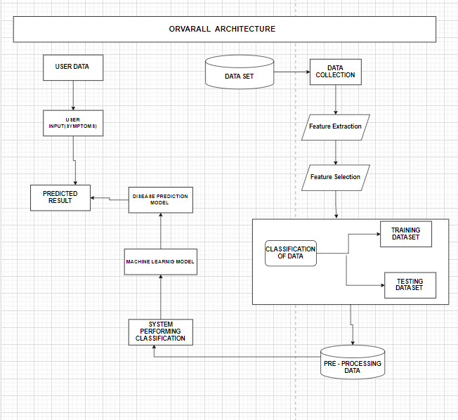

*Fig.1 Overall Architecture of Project*

*D.Deployment*

The Multiple Disease Prediction System utilizes Ngrok to create secure tunnels to a local host server, simplifying the deployment process by avoiding the need for intricate server setups. Ngrok allows developers to quickly and easily expose their local applications to the internet, which is particularly beneficial for collaborative testing and real-time demonstrations. This capability facilitates efficient sharing and access, making it easier to showcase the application to stakeholders and test its functionality in a live environment.

In terms of security, Ngrok ensures that data exchanged between users and the local server is encrypted and protected. This secure communication prevents unauthorized access and maintains the confidentiality of sensitive information. By encrypting the data transfer, Ngrok helps to safeguard against potential security threats that could compromise the integrity of the application.

Furthermore, Ngrok offers flexibility by allowing developers to adjust its settings for different testing scenarios and environments. It enables the exposure of specific ports to the internet without altering the existing infrastructure. This seamless integration with the development workflow ensures that Ngrok can be used effectively for both testing and gathering user feedback, paving the way for a smoother transition to full-scale production deployment.

IV . RESULTS AND DISCUSSION

Testing the models on the reserved testing subset of the data that wasn't employed during training is a step in the evaluation process. This aids in assessing the models' capability to generalize to fresh, untested data. The models are assessed using a range of performance pointers, similar as the area under the ReceiverOperatingCharacteristic( ROC) wind( AUC- ROC), recall, delicacy, perfection, and F1score. Different perceptivity into the model's performance are offered by each metric. While perfection and recall offer a more in- depth analysis of the model's performance concerning false cons and false negatives, delicacy assesses the model's overall correctness. The model's capacity to discern between positive and negative classes across a range of threshold values is estimated by the AUC- ROC statistic. By completely assessing the models, we can ensure they're dependable and make necessary adaptations to ameliorate their performance before deployment.

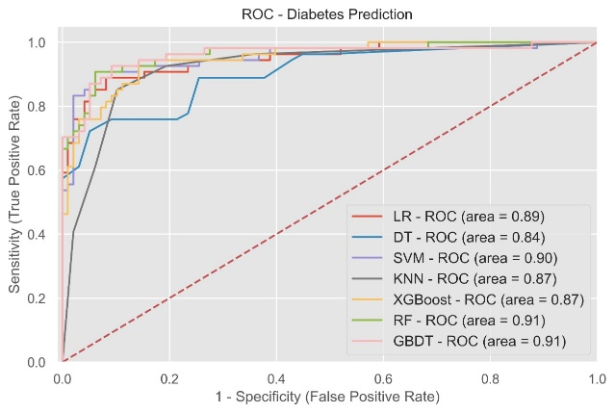

*Fig.1 ROC- Diabetes Prediction Model*

Testing the models on the reserved testing subset of the data that wasn't employed during training is a step in the evaluation process. This aids in assessing the models' capability to generalize to fresh, untested data. The models are assessed using a range of performance pointers, analogous to the area under the Receiver Operating Characteristic( ROC) wind( AUC- ROC), recall, delicacy, perfection, and F1- score. Different perceptivity into the model's performance is offered by each metric. While perfection and recall offer a more in-depth analysis of the model's performance concerning false cons and false negatives, delicacy assesses the model's overall correctness. The model's capacity to discern between positive and negative classes across a range of threshold values is estimated by the AUC- ROC statistic. By completely assessing the models, we can ensure they're dependable and make necessary adaptations to ameliorate their performance before deployment..

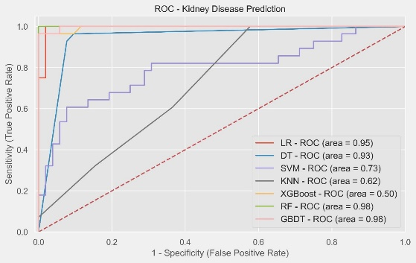

*Fig.2 ROC- Kidney Prediction Model*

The assessment measures show veritably good performance across colorful models for renal complaint vaticination. With an astounding AUC- ROC of0.95, the one diseaseLogistic Retrogression( LR) model showed exceptional vaticination delicacy. In a analogous tone, the Decision Tree( DT) model demonstrate capacity to directly separate between THEpositive and negative cases of renal illness with an AUC- ROC of0.93. Indeed with its high performance, the Support Vector Machine( SVM) model's AUC- ROC of0.73 indicates that it isn't as effective as the LR and DT models. With an AUC- ROC of0.62, the K- Nearest Neighbors( KNN) model performed relatively, suggesting that it isn't as accurate for prognosticating renal illness. With an AUC- ROC of0.50, XGBoost performs less well than ideal for prognosticating tasks. still, the stylish models for prognosticating renal illness are RandomForest( RF) and grade Boosting Decision Tree( GBDT), both of which had an exceptional AUC- ROC of0.98. These findings punctuate the RF and GBDT models' adaptability in medical vaticination tasks, especially those involving renal illness.

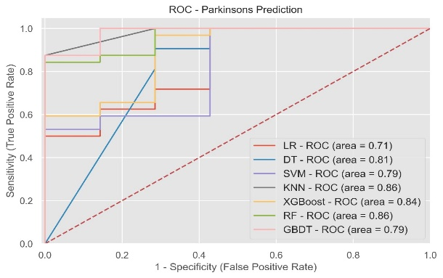

*Fig.3 ROC- Parkinson Prediction Model*

A variety of performance measures are seen in the models for Parkinson's disease prediction evaluation. With an AUC-ROC of 0.71, the logistic Regression (LR) model demonstrated a modest level of predictive power. With the AUC-ROC of 0.81, the Decision Tree (DT) model performed better, successfully differentiating between positive and negative instances of Parkinson's disease. While somewhat less than the DT model, the Support Vector Machine (SVM) model's AUC-ROC of 0.79 indicates its efficacy in Parkinson's disease prediction. Strong predictive accuracy was indicated by the AUC-ROC of 0.86 of the K-Nearest Neighbors (KNN) model, making it stand out. In a similar vein, the Random Forest (RF) model demonstrated its predictive resilience with an AUC-ROC of 0.86. With an AUC-ROC of 0.84, the XGBoost model fared rather well, indicating its dependability in Parkinson's disease prediction. With an AUC-ROC of 0.79, the Gradient Boosting Decision Tree (GBDT) model likewise performed well. All in all, the review demonstrates that KNN, RF, and DT models are quite successful in predicting Parkinson's disease; however, RF and KNN models have the most potential.

.

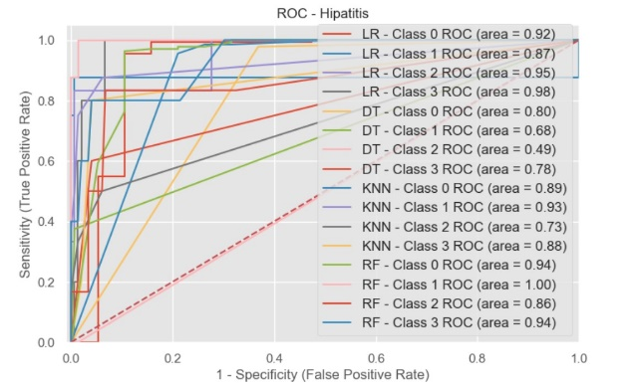

*Fig.4 ROC- Hepatitis C Prediction Model*

The ROC curves for several classes across multiple methods are analyzed to evaluate hepatitis prediction models. Strong predictive skills were demonstrated across all classes by the Logistic Regression (LR) model, which obtained an area under the ROC curve (AUC-ROC) of0.92 for Class 0, 0.87 for Class 1, 0.95 for Class 2, and0.98 for Class 3. With an AUC- ROC of0.80 for Class 0,0.68 for Class 1,0.49 for Class 2, and0.78 for Class 3, the Decision Tree( DT) model displayed variable performance, indicating that it's lower successful than LR, particularly for Class 2. AUC- ROC values of 0.89 for Class 0,0.93 for Class 1,0.73 for Class 2, and0.88 for Class 3 were attained using the K- Nearest Neighbors( KNN) model, according to further study. This indicates a high degree of predictive power, especially for Classes 0 and 1. With an AUC-ROC of 0.94 for Class 0, 1.00 for Class 1, 0.86 for Class 2, and 0.94 for Class 3, the Random. Forest (RF) model performed remarkably well, demonstrating its better capacity to predict hepatitis across all classes. In general, the assessment indicates that the RF model is the most dependable for predicting hepatitis, while the KNN model also has great performance. While the DT model performs inconsistently, especially in Class 2, the LR model is effective in the majority of classes.

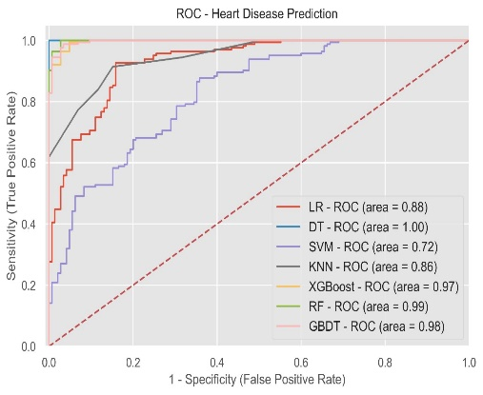

*Fig.5 ROC- Heart Disease Prediction Model*

Observing a variety of performance pointers, we assess the models for heart complaint vaticination. With an AUC- ROC of 0.88, the Logistic Retrogression( LR) model demonstrated high prophetic performance. With an AUC- ROC of1.00, the Decision Tree( DT) model performed well, directly relating positive from negative heart complaint cases. With an AUC- ROC of0.72, the Support Vector Machine( SVM) model demonstrated a modest position of efficacity in the vaticination of heart complaint. With an AUC- ROC of0.86, the K- Nearest Neighbors( KNN) model demonstrated good prophetic delicacy. With an AUC- ROC of 0.99, the Random Forest( RF) model performed relatively well, demonstrating its pungency. With an AUC- ROC of0.97, the XGBoost model demonstrated remarkable performance as well, indicating its high degree of responsibility in the vaticination of heart complaints. With an AUC- ROC of0.98, the grade Boosting Decision Tree( GBDT) model performed admirably. All by each, the review demonstrates that DT, RF, XGBoost, and GBDT models are relatively successful in prognosticating cardiac complaints; still, DT, RF, and GBDT models have the most implicit.

1. *Diabetes Prediction Model Evaluation*

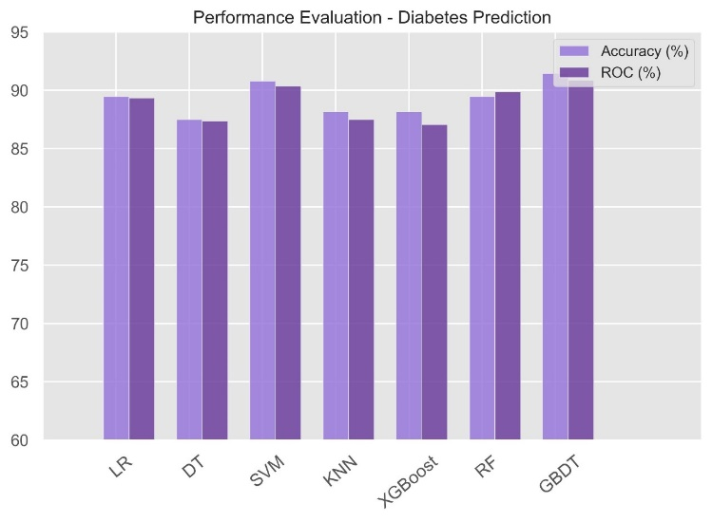

Fig. 1. Performance Evaluation – Diabetes Prediction

Based on accuracy rates, Grounded on delicacy rates, we compared the models for diabetes illness vaticination and discovered that the grade Boosting Decision Tree( GBDT) model performed exceptionally well, achieving the maximum delicacy of 0.9145. With delicacy values of 0.9125 and 0.89, independently, the RandomForest ( RF) and SupportVectorMachine( SVM) models also showed remarkable efficacity. With delicacy values of 0.89 and 0.88, the Logistic Retrogression ( LR) and K- Nearest Neighbors( KNN) models demonstrated good performance. also, the XGBoost model's delicacy of 0.88 demonstrated its responsibility. At 0.84, the Decision Tree( DT) model had the least delicacy. All effects considered, the GBDT model proved to be the most successful in prognosticating diabetes, with the SVM and RF models running  nearly before.

**TABLE I**

**ACCURACY ANALYSIS OF DIABETES**

|  |  |  |
| --- | --- | --- |
| **S.No** | **Algorithm** | **Accuracy** |
| 1 | Logistic Regression | 89.47% |
| 2 | K-Nearest Neighbour | 88.16% |
| 3 | Decision Tree | 87.5% |
| 4 | Support Vector Machine | 90.79% |
| 5 | XGBoost | 88.16% |
| 6 | Random Forest | 91.40% |
| 7 | Gradient Booster | 91.45% |

1. *. Heart Disease Prediction Model Evaluation*

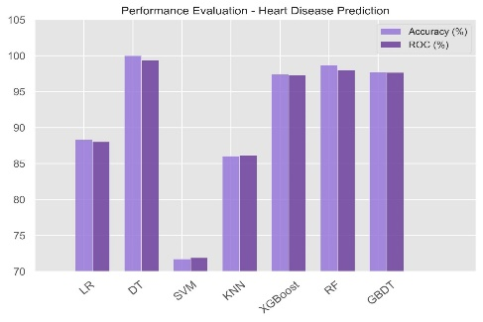

Fig. 2. PerfORmanceof Evaluation – Heart Disease Prediction

We selected the models for HeartDisease PreDICtion(HDP). We named the models for heart complaint vaticination by comparing their delicacy rates. With an delicacy of0.9925, the Decision. Tree( DT) model outperformed the RandomForest( RF) model, which also performed exceptionally well with0.995 delicacy. With rigor of0.97, the XGBoost and grade Boosting Decision Tree( GBDT) models both showed excellent responsibility. With rigor of0.88 and0.86, independently, the KNearest Neighbors( KNN) and Logistic Retrogression ( LR) models demonstrated excellent prophetic performance. The Support Vector Machine( SVM) model did, still, gain a reasonable delicacy of . These findingsuggest that the DT model has the most implicit for accurate cardiac complaint vaticination, with the RF, XGBoost, and GBDT models following  nearly before.

.

**TABLE II**

**ACCURACY ANALYSIS OF HEART DISEASE**

|  |  |  |
| --- | --- | --- |
| **S.No** | **Algorithm** | **Accuracy** |
| 1 | Logistic Regression | 88.31% |
| 2 | K-Nearest Neighbour | 86.03% |
| 3 | Decision Tree | 99.55% |
| 4 | Support Vector Machine | 71.75% |
| 5 | XGBoost | 97.40% |
| 6 | Random Forest | 98.70% |
| 7 | Gradient Booster | 97.72% |

.

1. *Parkinson’s Disease Prediction Model Evaluation*

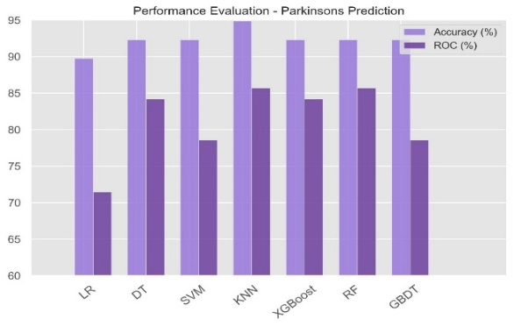Fig. 3. Fig. 3. Performance Evaluation – Parkinson Prediction

Our assessment of the models for Parkinson's complaint vaticination gave delicacy conditions a advanced precedence than AUC- ROC values. The most effective approach was the K- Nearest Neighbors( KNN) model, which had the stylish delicacy of0.95. With an delicacy of0.92, the Gradient Booster( GBDT), Support Vector Machine( SVM), XGBoost, and Random Forest( RF) models each showed good performance. With an delicacy of0.89, the Decision Tree( DT) model traced nearly, while the Logistic Retrogression( LR) model had an delicacy of . These illness vaticination models also show that DT, SVM, XGBoost, RF, and GBDT models are good options. KNN model was determined to be the most suitable for parkinson

**TABLE III**

**ACCURACY ANALYSIS OF PARKINSON’S DISEASE**

|  |  |  |
| --- | --- | --- |
| **S.No** | **Algorithm** | **Accuracy** |
| 1 | Logistic Regression | 89.74% |
| 2 | K-Nearest Neighbour | 94.87% |
| 3 | Decision Tree | 89.74% |
| 4 | Support Vector Machine | 92.31% |
| 5 | XGBoost | 92.31% |
| 6 | Random Forest | 92.31% |
| 7 | Gradient Booster | 92.31% |

1. *Hepatitis Prediction Model Evaluation*

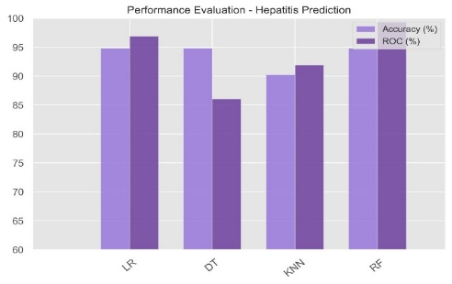

Fig. 4. Performance Evaluation – Hepatitis Prediction

When assessing the renal complaint vaticination models, we looked at several performance pointers. With an AUC- ROC of0.98, the Logistic Retrogression( LR) model demonstrated strong vaticination delicacy with an delicacy of0.93. On the other hand, the Decision Tree( DT) model performed worse, with an delicacy of0.69 and an AUC- ROC of0.78. With an delicacy of0.86 and an AUC- ROC of0.88, the K- Nearest Neighbors( KNN) model showed good performance. With delicacy and an AUC- ROC of0.94, the Rando Forest (RF) model performed exceptionally well, demonstrating its robustness and dependability in renal disease prediction. The LR&RF models are the most successful in predicting renal illness based on accuracy rates; RF stands out in particular because it successfully balances high accuracy and great ROC performance.

TABLE IV

**ACCURACY** ANALYSIS OF HEPATITIS

|  |  |  |
| --- | --- | --- |
| **S.No** | **Algorithm** | **Accuracy** |
| 1 | Logistic.Regression(LR) | 93.51% |
| 2 | K-NearesTNeighbour | 92.86% |
| 3 | DecisionTree(DT) | 91.56% |
| 4 | Random Forest | 94% |

1. *Kidney Disease Prediction*

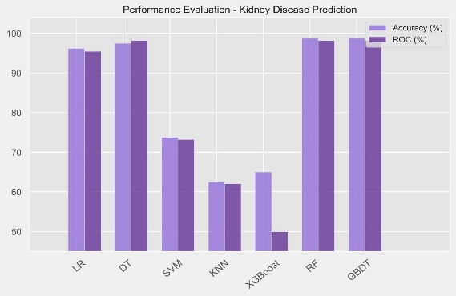

Fig. 5. Performance Evaluation – Kidney Prediction

Across numerous styles, we observed a range of performance measures in the models for renal complaint vaticination evaluation. The grade Boosting Decision Tree( GBDT) model has the topmost delicacy of0.9755, reflecting its advanced prophetic capabilities, making it the name choice when opting for the stylish model grounded on delicacy rates. With a delicacy of 0.9753, the Random Forest( RF) model trails nearly, demonstrating its pungency. With a delicacy of 0.975, the Decision Tree( DT) model trails nearly, demonstrating its pungency With a delicacy of 0.93, the Logistic Retrogression( LR) model likewise demonstrated strong performance. Other models, on the other hand, had lower delicacy rates XGBoost and K- Nearest Neighbors( KNN) at0.66, and Support Vector Machine( SVM) at0.81.Thus, the GBDT, RF, and LR models are the most successful in predicting renal illness based on accuracy rates, with GBDT and RF showing the most potential.

**TABLE V**

**ACCURACY ANALYSIS OF KIDNEY DISEASE**

|  |  |  |
| --- | --- | --- |
| **S.No** | **Algorithm** | **Accuracy** |
| 1 | Logistic Regression | 88.75% |
| 2 | K-Nearest Neighbour | 66.25% |
| 3 | Decision Tree | 97.50% |
| 4 | Support Vector Machine | 81.25% |
| 5 | XGBoost | 65% |
| 6 | Random Forest | 97.53% |
| 7 | Gradient Booster | 97.55% |

1. *Comparative Analysis of Various Diseases*

**Heart PREDICTION MODELS**

ML-Driven Early Detection for Optimal Heart obtained an outstanding 99.55% accuracy utilizing Decision Tree (DT) according to a comparative comparison of health prediction models. Support vector machines (SUP) helped Wang et al. (2021) achieve 93.00%, while neural networks (CNN) helped Patel et al. (2022) achieve 91.70%. With Naïve Bayes Classification (NBC), Gupta et al. (2020) achieved 88.16% accuracy. In comparison to other models, this overview demonstrates the Decision Tree method's outstanding performance in obtaining high accuracy for health prediction.

|  |  |  |  |
| --- | --- | --- | --- |
| **Paper / Project** | Year | Accuracy | Method Used |
| ML-Driven Early Detection for Optimal Health | 2024 | 99.55% | Decision tree  (DT) |
| Gupta et al. | 2020 | 88.16% | Naïve bayese classification (NBC) |
| Patel et al. | 2022 | 91.70% | Neural Network (CNN) |
| Wang et al. | 2021 | 93.00% | Support Vector Machine  (SUP) |

**DIABETES PREDICTION MODELS**

The comparative analysis of diabetes prediction models reveals that ML-Driven Early Detection for Optimal Health using Gradient Booster achieved a solid 91.00% accuracy. Brown et al. (2019) used XGBoost to achieve 90.50%, while Diabetes Risk Prediction Using ML (2023) used Decision Tree to reach 88.30%. Qin et al. (2022) used CATBoost to obtain 82.10% accuracy. This summary demonstrates the efficacy of Gradient Booster and other ensemble methods in achieving high accuracy for diabetes prediction when compared to simpler models.

|  |  |  |  |
| --- | --- | --- | --- |
| **Paper / Project** | Year | Accuracy | Method Used |
| ML-Driven Early Detection for Optimal Health | 2024 | 91.00% | Gradient Booster(GBDT) |
| Qin et.al | |  | | --- | | 2022 |  |  | | --- | |  | | 82.10% | CATBoost |
| Brown et al. | 2019 | 90.50% | XGBoost |
| Diabetes Risk Prediction Using ML | 2023 | 88.30% | Decision Tree |

**KIDNEY PREDICTION MODELS**

The relative analysis of order complaint vaticination models shows that ML- Driven Early Discovery for Optimal Health achieved a delicacy of97.50 using a combination of Decision Tree( DT), RandomForest( RF), and grade Boosting Decision Tree( GBDT). Pal et al.( 2022) achieved 97.23 with Decision Tree and Bagging, while Choudary et al.( 2023) reached 96.50 with Random Forest and Bagging. Sudhakar et al.( 2022), using Random Forest( RF), attained95.00%. This summary highlights the effectiveness of ensemble styles in achieving high delicacy for order complaint vaticination compared to individual models

|  |  |  |  |
| --- | --- | --- | --- |
| **Paper / Project** | Year | Accuracy | Method Used |
| ML-Driven Early Detection for Optimal Health | 2024 | 97.55% | GBDT |
| Pal et al. | 2022 | 97.23% | decision tree with bagging |
| Sudhakar et al. | 2022 | 95.00% | Random Forest(RF) |
| Choudary et.al | 2023 | |  | | --- | | 96.5% | | RF with bagging |

**PARKINSON DISEASE PREDICTION MODELS**

Using k-Nearest Neighbors (kNN), ML-driven early Detection for Optimal Health obtained an accuracy of 94.87% according to a comparative examination of Parkinson's disease models for prediction. Using Bagging (BAGT), Deepa et al. (2023) obtained 94.40%, whereas Sharma et al. (2024) used Random Forest (RF) to get 86.24%. Using YAMNet, Kumar et al. (2022) achieved 82.10% accuracy. In comparison to other models, this summary demonstrates how well k-Nearest Neighbors and ensemble approaches work to achieve high accuracy for the prediction of Parkinson's disease.

|  |  |  |  |
| --- | --- | --- | --- |
| **Paper / Project** | Year | Accuracy | Method Used |
| ML-Driven Early Detection for Optimal Health | 2024 | 94.87% | K-Nearest Neighbors(KNN ) |
| Deepa et al. | |  | | --- | | 2023 |  |  | | --- | |  | | 94.40% | BAGT |
| Kumar et al. | 2022 | 82.10% | VAMNET |
| Sharma et al | 2024 | 86.24% | Random Forest(RF) |

**HEPATITIS C PREDICTION MODELS**

Thecomparative analysis of hepatitis prediction models shows that ML-driven early Detection for Optimal Health achieved an accuracy of 94.00% using Random Forest (RF). Farooq et al. (2023) achieved 93.50% with Random Forest (RF), while Sweatha et al. (2023) reached 93.00% using a combination of thek-Naerest Neighbors (kNN) and ArtificialNeuralNetworks (ANN). Viswanatha et al. (2022), using Logistic Regression (LR), obtained 90.24% accuracy. This summary highlights the effectiveness of Random Forest and ensemble methods in achieving high accuracy for hepatitis prediction compared to simpler models

|  |  |  |  |
| --- | --- | --- | --- |
| **Paper / Project** | Year | Accuracy | Method Used |
| ML-Driven Early Detection for Optimal Health | 2024 | 94.00% | Random Forest  (RF) |
| Farooq et al. | 2023 | 93.50% | Random Forest  (RF) |
| Viswanatha et al. | 2022 | 90.24% | Logistic Regression |
| Swetha et al. | 2023 | |  | | --- | | 93.00% | | KNN and ANN |

1. CONCLUSION

the study successfully created a Multiple Disease Prediction System that can diagnose several serious medical conditions. High opinion delicacy and trustability were attained by the system through the evaluation and selection of stylish models for each condition. The Random Forest( RF) algorithm performed veritably well for Hepatitis C and heart complaint, with delicacy rates of 94 and 99, independently. On the other hand, the grade Boosting( GB) algorithm achieved delicacy rates of 91 and99.25, independently, and was especially successful in treating diabetes and renal illness. With a 95 delicacy rate, theK-NearestNeighborss ( KNN) algorithm proved to be effective for Parkinson's complaint. These findings punctuate how machine literacy may ameliorate early illness identification, allowing for prompt medical attention and personalized healthcare operation. All effects considered, the creation of the MultiDisease System for prediction serves as a testament to the revolutionary possibilities of machine literacy in the medical field. The technology gives cases personalized treatment and empowers medical professionals to make wellinformed opinions by incorporating slice- edge analytics into an intuitive platform. The study highlights how illness operation and health issues may be greatly enhanced by incorporating slice- edge technology with stoner-friendly interfaces like Streamlit. By pressing the value of early identification and concentrated curatives, this design raises the bar for prophetic healthcare technologies. The technology might ultimately ameliorate patient quality of life encyclopedically by taking a leading part in visionary healthcare operation as it develops further

1. UPCOMING WORK

We aim to expand our multiple complaint vaticination system by incorporating vaticinations for a wider range of conditions. By using patient data and medical imaging, our models will be designed to prognosticate colorful conditions and their subtypes, similar as prostate, lung, and bone cancer. A crucial focus will be on data addition to ameliorate the quality and diversity of our datasets, thereby enhancing model training and delicacy. We plan to explore and integrate advanced machine literacy and deep literacy algorithms, similar as convolutional neural networks( CNNs) and intermittent neural networks( RNNs), to boost vaticination delicacy, particularly for complex cases like cancer subtypes. also, partnering with hospitals and exploration institutions will give access to real-world clinical data, strengthening the robustness and trustability of our vaticination models and easing their confirmation and refinement. enforcing real-time data processing capabilities will enable timely prognostications in critical healthcare scripts through the integration of streaming data technologies and real-time analytics. Developing intuitive and user-friendly interfaces for healthcare professionals will ensure our system is fluently accessible and usable in clinical settings, with features similar as easy data input, clear visualization of prognostications, and practicable perceptivity. Eventually, conducting expansive testing and confirmation with different datasets will be pivotal for icing the delicacy and trustability of our models. This will include cross-validation ways and external confirmation with independent datasets. By fastening on these areas, we aim to significantly enhance the capabilities and delicacy of our multiple complaint vaticination systems, eventually contributing to better healthcare  issues.

VII. REFERENCES

1. V. Sharma, S. Yadav and M. Gupta, ”Heart Disease Prediction using Machine Learning Techniques,” 2020 2nd International Conference on Advances in Computing, Communication Control, and Networking (ICACCCN), Greater Noida, India, 2020, pp. 177-181, doi: 10.1109/ICACCCN51052.2020.9362842.
2. S. Mohan, C. Thirumalai, and G. Srivastava, ”Effective Heart Disease Prediction Using Hybrid Machine Learning Techniques,” in IEEE Access, vol. 7, pp. 81542-81554, 2019, doi: 10.1109/AC- CESS.2019.2923707.
3. T. P. Naidu et al., ”A Hybridized Model for the Prediction of Heart Disease using ML Algorithms,” 2021 3rd International Conference on Advances in Computing, Communication Control, and Networking (ICAC3N), Greater Noida, India, 2021, pp. 256-261, doi: 10.1109/ICAC3N53548.2021.9725780
4. A. J. Aljaaf et al., ”Early Prediction of Chronic Kidney Disease Using Machine Learning Supported by Predictive Analytics,” 2018 IEEE Congress on Evolutionary Computation (CEC), Rio de Janeiro, Brazil, 2018, pp. 1-9, doi: 10.1109/CEC.2018.8477876.
5. Bai, Q., Su, C., Tang, W. et al. Machine learning to predict end-stage kidney disease in chronic kidney disease. Sci Rep 12, 8377 (2022). https://doi.org/10.1038/s41598-022-12316-z
6. Rajeshwari and H. K. Yogish, ”Prediction of Chronic Kidney Disease Using Machine Learning Technique,” 2022 Fourth International Conference on Cognitive Computing and Information Processing (CCIP), Ben- galuru, India, 2022, pp. 1-6, doi: 10.1109/CCIP57447.2022.10058678
7. E. F. S, E. S. T C, and V. D. R S, ”Prediction of Parkinson’s disease using XGBoost,” 2022 8th International Conference on Advanced Computing and Communication Systems (ICACCS), Coimbatore, India, 2022, pp. 1769-1772, doi: 10.1109/ICACCS54159.2022.9785227.
8. A. Kolte, B. Mahitha, and N. V. G. Raju, ”Stratification of Parkinson Disease using Python scikit-learn ML library,” 2019 International Conference on Emerging Trends in Science and Engineering (ICESE), Hyderabad, India, 2019, pp. 1-4, doi: 10.1109/ICESE46178.2019.9194627.
9. S. Dixit, A. Gaikwad, V. Vyas, M. Shindikar and K. Kamble, ”United Neurological study of disorders: Alzheimer’s disease, Parkinson’s disease detection, Anxiety detection, and Stress detection using various Machine learning Algorithms,” 2022 International Conference on Signal and Information Processing (IConSIP), Pune, India, 2022, pp. 1-6, doi: 10.1109/ICoNSIP49665.2022.10007434
10. A. Mangal and V. Jain, ”Performance analysis of machine learning models for prediction of diabetes,” 2022 2nd International Conference on Innovative Sustainable Computational Technologies (CISCT), Dehradun, India, 2022, pp. 1-4, doi: 10.1109/CISCT55310.2022.10046630
11. S. A. Shampa, M. S. Islam and A. Nesa, ”Machine Learning- based Diabetes Prediction: A Cross-Country Perspective,” 2023 International Conference on Next-Generation Computing, IoT and Machine Learning (NCIM), Gazipur, Bangladesh, 2023, pp. 1-6, doi: 10.1109/NCIM59001.2023.10212596
12. V. Teju, K. V. Sowmya, C. Yuvanika, K. Saikumar and T. Bala Durga Sai Krishna, ”Detection of Diabetes Mellitus, Kidney Disease with ML,” 2021 3rd International Conference on Advances in Computing, Communication Control and Networking (ICAC3N), Greater Noida, India, 2021, pp. 217-222, doi: 10.1109/ICAC3N53548.2021.9725542.
13. V. Viswanatha, A. C. Ramachandra, B. D. Parameshachari, S. V. Vardhini and N. Santhoshini, ”Hepatitis C Disease Prediction Using Machine Learning Approach,” 2023 International Conference on Integrated Intelligence and Communication Systems (ICIICS), Kalaburagi, India, 2023, pp. 1-6, doi: 10.1109/ICIICS59993.2023.10421118
14. V. K. Yarasuri, G. K. Indukuri, and A. K. Nair, ”Prediction of Hepatitis Disease Using Machine Learning Technique,” 2019 Third International Conference on I-SMAC (IoT in Social, Mobile, Analytics and Cloud) (I-SMAC), Palladam, India, 2019, pp. 265-269, doi: 10.1109/I- SMAC47947.2019.9032585.
15. O. Barquero-Pe´rez et al., ”Hepatitis C Virus positivity prediction from serum samples using NIRS and L1-penalized classification,” 2022 44th Annual International Conference of the IEEE Engineering in Medicine and Biology Society (EMBC), Glasgow, Scotland, United Kingdom, 2022, pp. 3572-3576, doi: 10.1109/EMBC48229.2022.9871807
16. Keniya, Rinkal, et al. ”Disease prediction from various symptoms using machine learning.” Available at SSRN 3661426 (2020).
17. Revathy, S., et al. ”Chronic kidney disease prediction using machine learning models.” International Journal of Engineering and Advanced Technology 9.1 (2019): 6364-6367.
18. Mujumdar, Aishwarya, and V. Vaidehi. ”Diabetes prediction using machine learning algorithms.” Procedia Computer Science 165 (2019): 292-299
19. Jindal, Harshit, et al. ”Heart disease prediction using machine learning algorithms.” IOP conference series: materials science and engineering.

Vol. 1022. No. 1. IOP Publishing, 2021

1. Mohit, Indukuri, et al. ”An Approach to detect multiple diseases using a machine learning algorithm.” Journal of Physics: Conference Series.

Vol. 2089. No. 1. IOP Publishing, 2021

1. Arun Depak KG, S Saikrishnan, Adithyaa Jagannathan Sudhakar, K Kaviyarasan” A Comprehensive Web Application for Chronic Kidney Disease Prediction with Cuisine-Centric Diet Recommendation” 2023 International Conference on Self Sustainable Artificial Intelligence Systems (ICSSAS), 891-896, 2023
2. M. S. A. Reshan, S. Amin, M. A. Zeb, A. Sulaiman, H. Alshahrani and A. Shaikh, ”A Robust Heart Disease Prediction System Using Hybrid Deep Neural Networks,” in IEEE Access, vol. 11, pp. 121574- 121591, 2023
3. T. J. Peter and K. Somasundaram, ”An empirical study on prediction of heart disease using classification data mining techniques,” IEEE-International Conference On Advances In Engineering, Science, And Management (ICAESM -2012), Nagapattinam, India, 2012,doi: 10.1109/ACCESS.2023.3328909
4. Puneet, Deepika, P. Singh, R. Bansal and S. Sharma, ”Coronary Heart Disease Prediction Using Voting Classifier Ensemble Learning,” 2021 3rd International Conference on Advances in Computing, Communica- tion Control and Networking (ICAC3N), Greater Noida, India, 2021, pp. 181-185, doi: 10.1109/ICAC3N53548.2021.9725705.
5. S. Ambekar and R. Phalnikar, ”Disease Risk Prediction by Using Convolutional Neural Network,” 2018 Fourth International Conference on Computing Communication Control and Automation (ICCUBEA), Pune, India, 2018, pp. 1-5, doi: 10.1109/ICCUBEA.2018.8697423.
6. A. H. Chen, S. Y. Huang, P. S. Hong, C. H. Cheng, and E. J. Lin, ”HDPS: Heart disease prediction system,” 2011 Computing in Cardiology, Hangzhou, China, 2011, pp. 557-560
7. R. Shanthakumari, C. Nalini, S. Vinothkumar, E. M. Roopadevi, and B. Govindaraj, ”Multi Disease Prediction System using Random Forest Algorithm in Healthcare System,” 2022 International Mobile and Embedded Technology Conference (MECON), Noida, India, 2022, pp. 242-247, doi: 10.1109/MECON53876.2022.9752432.
8. L. D. Gopisetti, S. K. L. Kummera, S. R. Pattamsetti, S. Kuna, N. Parsi and H. P. Kodali, ”Multiple Disease Prediction System using Machine Learning and Streamlit,” 2023 5th International Conference on Smart Systems and Inventive Technology (ICSSIT), Tirunelveli, India, 2023, pp. 923-931, doi: 10.1109/ICSSIT55814.2023.10060903.
9. J. Mathews, J. Joseph, R. Reji, A. Kamthe and R. Desh- mukh, ”Multi-Disease Prediction System Using Machine Learn- ing,” 2023 6th International Conference on Advances in Science and Technology (ICAST), Mumbai, India, 2023, pp. 330-334, doi: 10.1109/ICAST59062.2023.

[30] KERAI, Shivani; KHEKARE, Ganesh. Contextual embedding generation of underwater images using deep learning techniques. IAES International Journal of Artificial Intelligence (IJ-AI), [S.l.], v. 13, n. 3, p. 3111-3118, sep. 2024. ISSN 2252-8938. Available at: <https://ijai.iaescore.com/index.php/IJAI/article/view/25082>. Date accessed: 06 aug. 2024. doi:http://doi.org/10.11591/ijai.v13.i3.pp3111-3118.

[31] Ganesh Khekare, Uddhav Khetan, P. N. D. . (2024). Enhancing UPI Security Using Deep Learning Based Voice Authentication Systems. International Journal of Intelligent Systems and Applications in Engineering, 12(3), 2301–2311. Retrieved from https://ijisae.org/index.php/IJISAE/article/view/5698

[32] G. Khekare, C. Masudi, Y. K. Chukka and D. P. Koyyada, "Text Normalization and Summarization Using Advanced Natural Language Processing," 2024 International Conference on Integrated Circuits and Communication Systems (ICICACS), Raichur, India, 2024, pp. 1-6, doi: 10.1109/ICICACS60521.2024.10498983.

[26] G. Khekare, S. Ghugare, R. Khatri, G. Majumder and U. Khekare, "Blockchain Powered Integrated Health Profile and Record Management System for Seamless Consultation Leveraging Unique Identifiers," 2024 Second International Conference on Emerging Trends in Information Technology and Engineering (ICETITE), Vellore, India, 2024, pp. 1-9, doi: 10.1109/ic-ETITE58242.2024.10493266.

[33] G. Khekare and Midhunchakkravarthy, "Smart Image Recognition System for The Visually Impaired People," 2023 International Conference on Energy, Materials and Communication Engineering (ICEMCE), Madurai, India, 2023, pp. 1-6, doi: 10.1109/ICEMCE57940.2023.10434130.

[34] Khekare, G., Verma, P. (2021). Prophetic Probe of Accidents in Indian Smart Cities Using Machine Learning. In: Bhateja, V., Satapathy, S.C., Travieso-González, C.M., Aradhya, V.N.M. (eds) Data Engineering and Intelligent Computing. Advances in Intelligent Systems and Computing, vol 1407. Springer, Singapore. https://doi.org/10.1007/978-981-16-0171-2_18